**IMPORTANT**:

In case of reduction of flow rate, close the two main inlets

and check if the filter at the bottom of the non-return valve are dirty,

### in this case clean them.

#### CARTRIDGE CHANGE AND CLEANING

Through years of use, impurities and lime scale could restrict flow of water through the filters of the cartridge. To clean it:

* Shut off water supply to both inlets.
* Remove the temperature control handle.
* Unscrew cartridge using a spanner. Wash filters under running water or leave to soak in vinegar or de-scaling agent.
* Before re-assembling cartridge clean its housing with wet cloth and grease “O” rings on cartridge. WRAS approved grease should be used.
* Re-assembling cartridge into body.
* Re-fit temperature handle, taking care to ensure correct alignment.

**GUARANTEE**

The shower valve is guaranteed for a period of 2 years against any defects of materials

and workmanship from date of purchase, subject to correct installation, maintenance

and use in accordance with this instruction leaflet. Optional extension to 5 years is

available, please refer to Product Guarantee Registration Card included in the box.

Please retain proof of purchase.

The guarantee does not cover:

* Those components subject to wear and tear such as 'O' rings and washers etc.
* Damage caused by faulty installation or maintenance
* Damage caused by any waterborne debris
* Damage caused by improper cleaning products
* The product being used for a purpose other than intended
* Damage caused by other products or materials
* Damage caused by frost; product should be adequately drained in freezing

conditions

**AFTERCARE INSTRUCTIONS**

Whilst modern plating techniques are used in the manufacture of this item, the

surfaces will wear if not cleaned correctly. Clean this product with a soft cloth and

clean water. The use of any abrasive material will invalidate the guarantee.

Manufactured for GM Distribution.

Customer Helpline +44 (0)845 257 6973

CVN26261/10-04



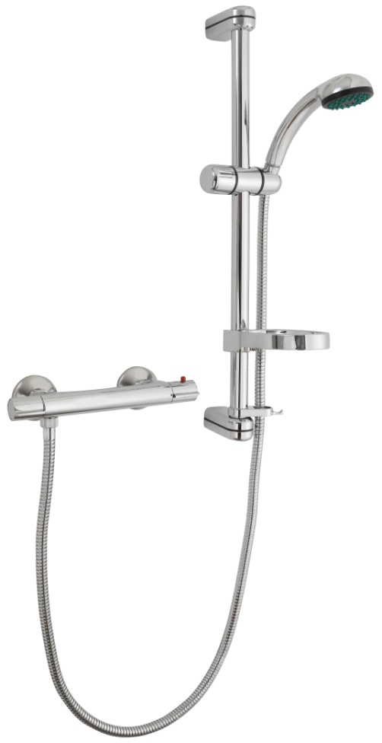

COMBI BAR SHOWER SET

## **TROUBLESHOOTING**

1. AFTER SALES SERVICE

**Under no circumstances should the product be uninstalled even if you think it is faulty**. It is easier to diagnose faults and/or installation errors when the product is in situ. As most errors can be diagnosed by calling the helpline, products uninstalled without the authorisation of customer services will be sent for testing prior to credit. A charge to cover the costs of administration and handling will be made where no fault can be found with the product.

1. REDUCED FLOW RATE

*Cause:* The inlet filters of the mixer and/or the cartridge are obstructed.

*Solution:* Cleaning filters and/or cartridge: refer to “CARTRIDGE CHANGE AND CLEANING”

Cleaning mixer filters: refer to “FILTER CLEANING”

1. WRONG SETTING OF THE CARTRIDGE

*Causes:* The mixer is factory preset at 2,5-3 bar and at a temperature of 60-65°C for hot water and 10-15°C for the cold one corresponding to a mixing temperature of 38°C. In every domestic installation temperatures and inlets pressures can differ from those of production.

*Solution:* Take the water temperature, using a common thermometer for domestic use

Remove the temperature control handle

Turn the broached ring of the cartridge until the blended water reaches the desired temperature

Re-assemble the temperature control handle.

1. CONTINUOUS TEMPERATURE OSCILLATIONS

*Cause:* The mixer has been installed with the inverted inlets

*Solution:* Close the main water supply

Remove the valve body: refer to “FILTER CLEANING”

Reverse the hot and cold supply inlets.

Re-install the valve body

## **INSTALLATION**

**The hot water inlet must be on the left side of the mixer**

* This unit is high pressure only (in excess of 0.bar – 7.25 PSI)
* Place the mixer in the correct position and mark the inlet position.
* Plumb the hot and cold water pipes to the desired mixer position.
* **Ensure that the pipe-work is flushed prior to the attaching the mixer valve.**
* Using suitable ½” BSP FI connectors (not supplied), Fit the hot & cold inlet ‘Z’ connectors. (if required an optional wall mounting plate can be purchased separately)
* Place the mixer onto the ‘Z’ connectors and secure using the union connections.
* Install the shower kit and connect the hose to the mixer outlet.
* Test and ensure that the unit functions correctly.

#### GENERAL CHARACTERISTICS

In the case of instantaneous water heaters, hot water flow has to at least meet the minimum flow rate required by the water heater.

(Specified by heater manufacturer)

#### OPERATING SPECIFICATIONS

Hot water supply temperature:

Maximum: 85°C

Minimum: 5°C Higher than maximum required mixed temperature.

Recommended: 65°C.

Recommended minimum temperature differential between hot inlet and mixed temperature is 10°C.

## Operating Pressure

Maximum: 5 Bar

Minimum: 0.5 Bar

**MAXIMUM PRESSURE DIFFERENTIAL RATIO 5:1**

Operating pressure (on hot and cold line) should be kept as balanced as possible in order to assure maximum efficiency.

When the pressure is higher than a 5 bar, a pressure reducing valve should be fitted to the incoming supply.

#### PLUMBING RECOMMENDATIONS

* An independent water supply (both hot and cold) is recommended.
* Large runs of pipe work will cause frictional loss of pressure.
* For gravity fed systems, the recommended supply from both cylinder and water tank should be 22 mm minimum reducing to 15 mm within half a metre of valve.
* If more than one shower valve is installed the minimum feed from tank and cylinder should be 28 mm, reducing to 15 mm within half a meter valve. (Ensure adequate supply of both hot and cold water can be maintained).
* For installations where a booster pump is required, a twin impeller pump installed before the shower mixer inlets is recommended.

#### WATER BYE-LAWS

The mixing valve should be installed in compliance with the water bye-laws. For further details refer to the latest copy of water bye-laws guide or your local water authority.

